Piece | Issue | Answer
All | Can you confirm the English spellings of all the composers. The original list provided sometimes is different from what’s the spelling in the bio. Eg. Xie Xiangming combines the words but in the document you sent us it has Xie Xiang Ming.
2 | Can we cut anything from the Bio, such as the Gramophone Review and birth year? It’s getting too long and extending to the next page [Fig. 1]
3 | Bio – the last line of the English bio ends with ‘etc.’ could we change it to ‘and more’ or something similar? [Fig. 2]
 | We added his performance notes, but do you think we need the string divisi section [Fig. 3]
5 | Bio – Similar to Piece 2, it’s much longer. It’s fine to keep it this way and we could just remove the blank page at the end for cases where the bio is longer than a page. [Fig. 4]
8 | The bio is slightly long, but can be resolved if we make font size 11 instead of 12. English bio also ends with etc. - maybe we can fix that?
SCO Works – Front Matter Errata

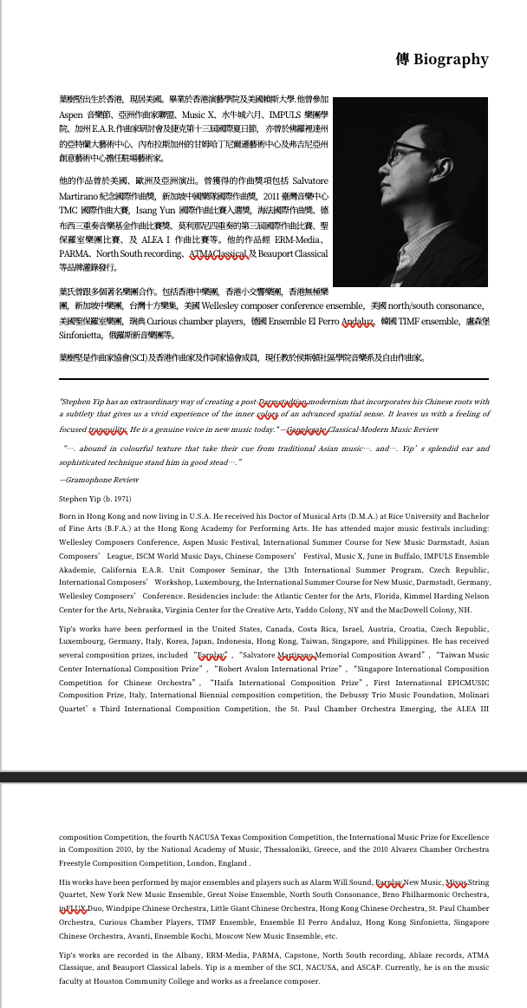
Figure 1: Piece 2 Bio too long

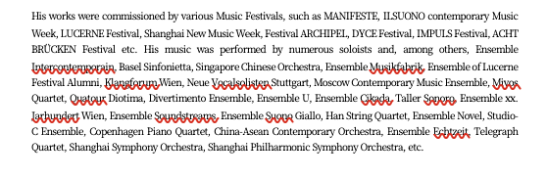
Figure 2: Piece 3 bio ends with 'etc.'

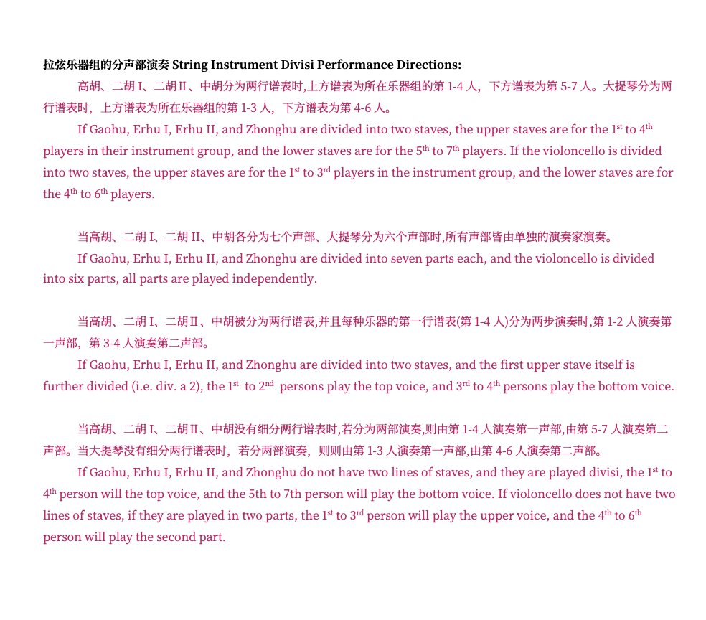
Figure 3: Piece 3 Programme Notes have a large section on strings divisi - needed?
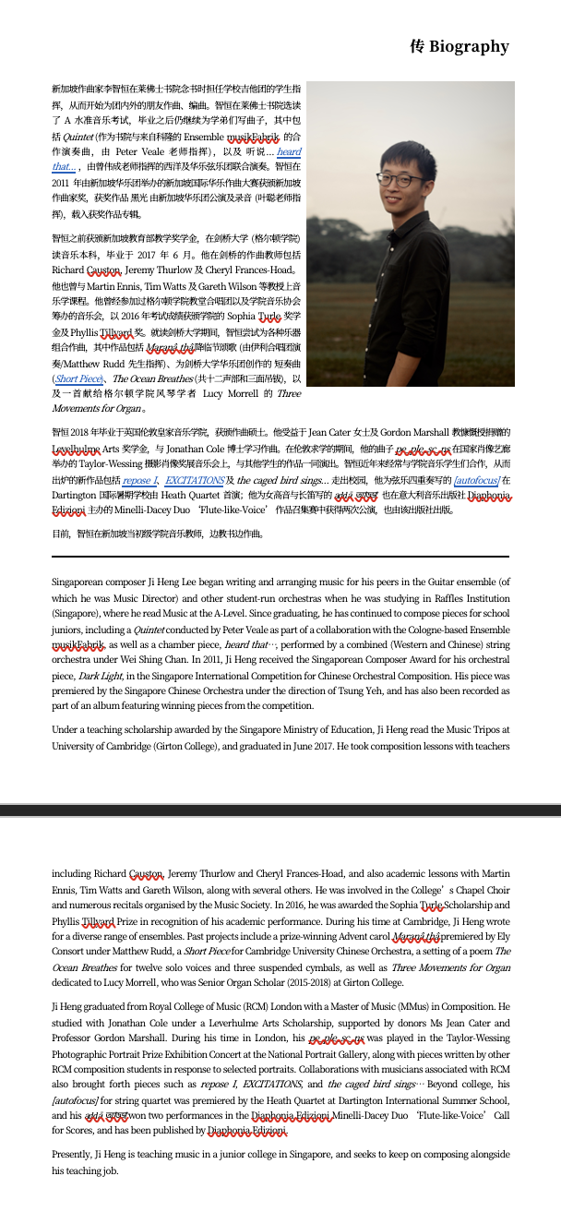
Figure 4: Piece 5 bio too long

